**Linear Regression on Original Data**

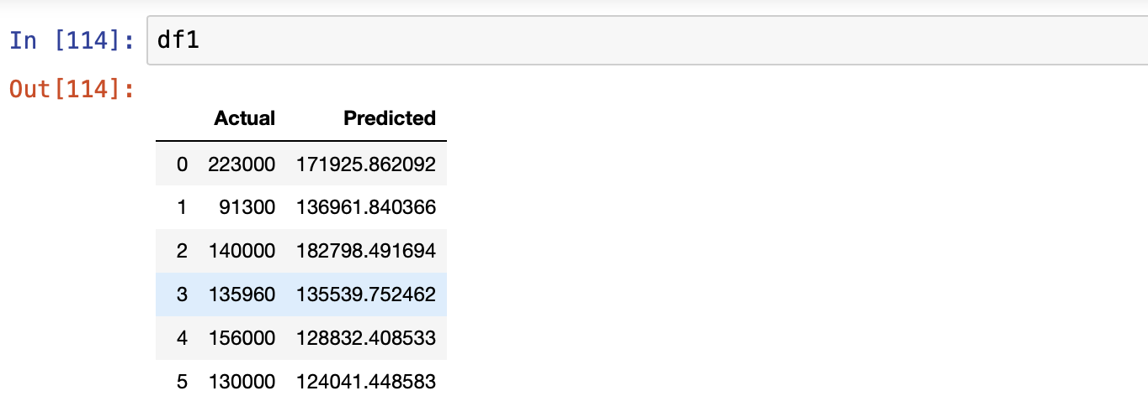

**Linear Regression on Cleaned Data**

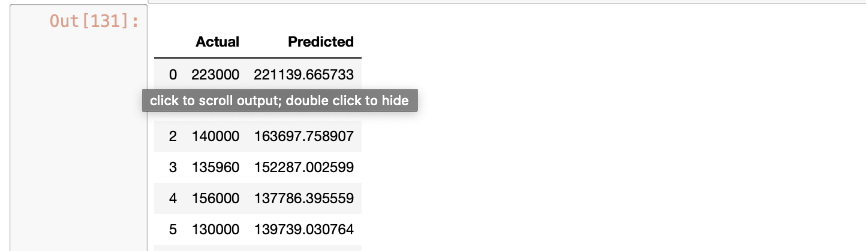

Now From above two screenshots you can see that the predicted value of sale price is significantly close to the actual value when we applied linear regression on cleaned data.

So we can conclude that by reducing features we can achieve

More accuracy and correct predictions.

**Gradient Descent**

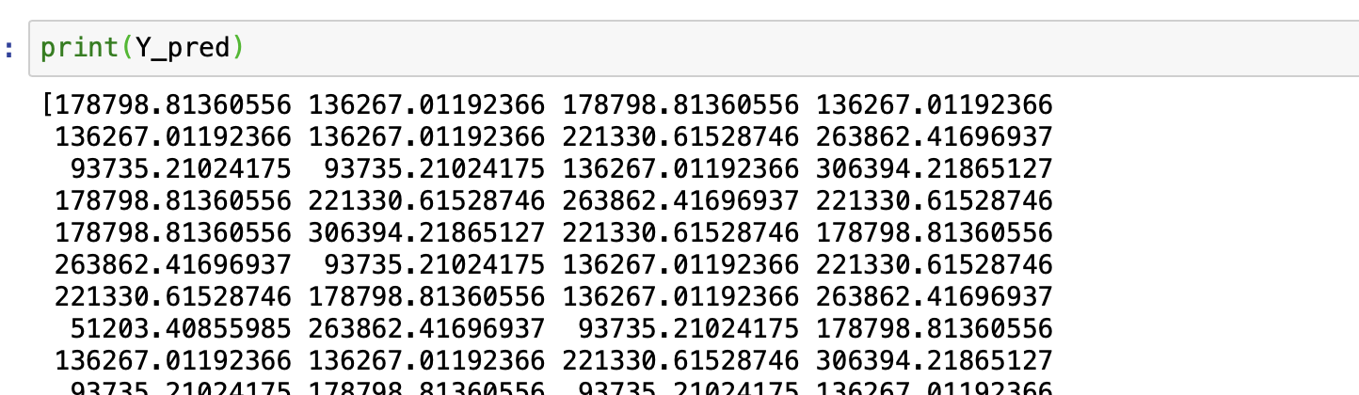

By comparing predicted values of linear regression and gradient descent we conclude that in our case linear regression model gives us better results.